Google Cloud Monitoring
Tasks
1.
Set up a free monitoring tool like AWS CloudWatch, Azure Monitor, or Google Cloud Monitoring and create a new alert rule for CPU usage exceeding 70% on a virtual machine or cloud resource.
2.
Configure an email notification for your alert rule so that you receive an email whenever the CPU usage crosses the threshold.<br><br><em><strong>Hint:</strong> Use your own Gmail or Outlook address for testing the notification delivery.</em>
3.
Simulate high CPU usage on your resource (for example, by running a CPU-intensive script or process) and verify that your alert triggers and sends a notification.
4.
Edit your alert rule to add a second condition: notify if memory usage goes above 80% as well, and test that both conditions work as expected.<br><br><em><strong>Hint:</strong> You may need to install monitoring agents or enable additional metrics for memory tracking.</em>
5.
Review your alert configuration and write 3 improvements you would make to reduce false alarms or make notifications more useful for a real-world app like Zomato or Flipkart.

Answer : 1. Create a VM
We’ll use Amazon EC2 as the resource whose CPU we monitor.
- Sign in to the AWS Management Console.
- Search for EC2.
- Click Launch instance.
- Give it a name such as Monitoring-Test-VM.
- For the operating system, choose Ubuntu or Amazon Linux.
- Choose a small eligible instance type, such as t2.micro/t3.micro if available under your account's free-tier terms.
- Create/select a key pair so you can connect to the VM.
- Launch the instance.
- Wait until its status becomes Running.
Little info:
An EC2 instance is basically a virtual computer in AWS. CloudWatch can monitor things happening on that computer.

2. Open CloudWatch
- In AWS Console, search for CloudWatch.
- Open CloudWatch.
- In the left menu, find Alarms.
- Click All alarms.
- Click Create alarm.
You'll now create the CPU alert.

3. Create the CPU >70% alarm
- Click Select metric.
- Choose:
EC2 → Per-Instance Metrics
- Find your EC2 instance.
- Select CPUUtilization.
- Click Select metric.
Configure the alarm approximately like this:
- Statistic: Average
- Period: 1 minute
- Threshold type: Static
- Condition: Greater than
- Threshold: 70
For example:
CPUUtilization > 70%
Period: 1 minute
You can also set Datapoints to alarm to something like:
1 out of 1
This makes the alarm trigger when one measurement exceeds 70%.
Click Next.

4. Configure the email notification
On the notification section:
- Choose Create new SNS topic.
- Give it a name such as:
CPU-Alert-Notifications
- Enter your Gmail or Outlook address.
- Create the topic.
- Continue creating the alarm.
AWS will send a confirmation email to that address.

Very important
Open your Gmail/Outlook inbox and click the Confirm subscription link.
If you don't confirm the subscription, AWS won't deliver the alarm notification to you.
Finally:
- Give the alarm a name, e.g.
EC2-CPU-Above-70
- Create the alarm.
Little info:
Amazon SNS is the AWS service that sends the notification. CloudWatch detects the problem → SNS sends the email.

5. Test high CPU usage
Now we need to deliberately make the VM use lots of CPU.
Connect to your EC2 instance using SSH.
For Ubuntu, you can use something like:
ssh -i your-key.pem ubuntu@YOUR_PUBLIC_IP
Once connected, you can generate CPU load.
For example, install/use stress-ng:
sudo apt update
sudo apt install stress-ng -y
Then run:
stress-ng --cpu 2 --timeout 5m
This creates CPU-intensive work for about 5 minutes.
You can check CPU usage with:
top
or:
htop
If htop isn't installed:
sudo apt install htop -y

What should happen?
Your CPU usage should rise above 70%.
Then:
EC2
↓
CPU > 70%
↓
CloudWatch detects it
↓
Alarm changes to ALARM
↓
SNS
↓
Email arrives
CloudWatch metrics aren't necessarily instantaneous, so give it several minutes.

6. Add memory monitoring
This part is slightly different.

Why?
CloudWatch provides EC2 CPU metrics by default, but memory utilization isn't normally available as a standard EC2 metric.
You need to install/configure the CloudWatch Agent to collect memory information.
On your EC2 instance, install the CloudWatch agent.
For Ubuntu, AWS provides installation packages and configuration instructions. The official AWS documentation is the safest reference for the exact current commands:
AWS CloudWatch Agent documentation
The basic idea is:
EC2
↓
CloudWatch Agent
↓
Collect memory usage
↓
CloudWatch
When configuring the agent, enable a memory metric such as:
mem_used_percent
After the agent is running, wait for the metric to appear in CloudWatch.

7. Create the memory >80% alarm
Go back to:
CloudWatch → Alarms → Create alarm
Find the CloudWatch Agent metric for your EC2 instance.
Select:
mem_used_percent
Configure:
Statistic: Average
Period: 1 minute
Condition: Greater than 80
So your rule becomes:
Memory usage > 80%
Use the same SNS notification topic if you want both alarms to send email to the same address.
Give it a name such as:
EC2-Memory-Above-80

8. Test the memory alarm
You can use a memory stress tool.
For Ubuntu:
sudo apt install stress-ng -y
Then, depending on how much RAM your VM has, you can test with something like:
stress-ng --vm 1 --vm-bytes 85% --timeout 5m
This attempts to use around 85% of available memory.
Check:
free -h
or:
top
Then check CloudWatch.
You should eventually see:
Memory > 80%
↓
CloudWatch Alarm
↓
SNS
↓
Email
Be careful: On a very small VM, allocating too much memory can cause instability. Keep the test short and use a conservative percentage.

9. What you should demonstrate for your assignment
Your final setup should look approximately like this:
AWS EC2
|
+---------+---------+
| |
CPUUtilization mem_used_percent
| |
> 70% > 80%
| |
+---------+---------+
|
CloudWatch Alarm
|
SNS
|
Gmail / Outlook
Take screenshots of:
- EC2 instance running
- CPU CloudWatch alarm
- SNS email subscription confirmed
- CPU alarm in ALARM state
- CPU notification email
- CloudWatch memory metric
- Memory >80% alarm
- Memory alarm/notification
These screenshots will make your assignment much easier to prove.

10. Three improvements for a real app like Zomato/Flipkart
For a real production application, I would make these three improvements:

1. Require sustained high usage
Instead of triggering immediately when CPU reaches 70%, require something like:
CPU > 70%
for 5 consecutive minutes
Why? A short CPU spike is normal. This reduces false alarms.

2. Use different severity levels
For example:
CPU > 70% → Warning
CPU > 85% → High
CPU > 95% → Critical
Critical alerts could notify the on-call engineer through a more urgent notification channel.

3. Add useful context to notifications
Instead of an email that simply says:
CPU is high
include:
Application: Zomato
Server: orders-api-03
CPU: 91%
Memory: 84%
Region: Mumbai
Time: 10:30 PM
Alarm: Production CPU High
This lets the engineer understand the problem immediately rather than searching through CloudWatch first.

Short explanation you can remember
For your viva/presentation, remember this:
CloudWatch = monitors AWS resources.
Metric = measurement, such as CPU or memory.
Alarm = rule that checks a metric against a threshold.
SNS = sends notifications.
CloudWatch Agent = collects additional information such as memory usage from an EC2 machine.
So the overall process is:
EC2 → CloudWatch → Alarm → SNS → Email
If you tell me whether you're using AWS, Azure, or Google Cloud, I can also walk you through the exact console buttons/screens for your chosen platform, one step at a time.
1. Example: Select CPU metric
Go to:
AWS Console → CloudWatch → Alarms → Create alarm → Select metric → EC2 → Per-Instance Metrics
Find your EC2 instance and select CPUUtilization.
This is what the screen looks similar to:
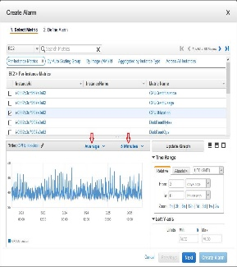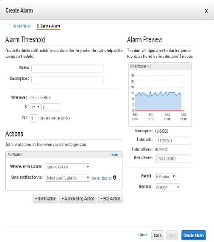
AWS's current documentation confirms that the CPU alarm is created from EC2 → Per-Instance Metrics → CPUUtilization. AAWS Docs

Example settings
Use:
Setting | Example
Metric | CPUUtilization
Statistic | Average
Period | 1 or 5 minutes
Condition | Greater than
Threshold | 70%
Alarm name | EC2-CPU-Above-70
So your rule means:
"If average CPU usage goes above 70%, trigger the alarm."

2. Example: Email notification
When you reach the Notification section, select/create an SNS topic and enter your Gmail/Outlook address.
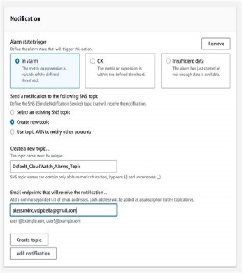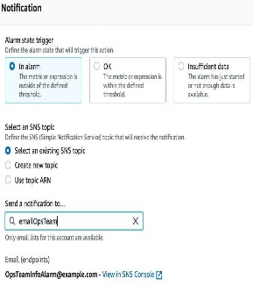
For example:
Alarm:
EC2-CPU-Above-70

Condition:
CPU > 70%

Notification:
myemail@gmail.com
AWS sends a subscription-confirmation email. You must click the confirmation link before SNS can send alarm notifications to that address. AAWS Docs

3. Example: Create the CPU alarm
Your final configuration could look like:
Metric:
CPUUtilization

Statistic:
Average

Period:
1 minute

Condition:
Greater than 70%

Datapoints:
1 out of 1

Notification:
SNS → Gmail

Alarm name:
EC2-CPU-Above-70
Then click:
Next → Next → Review → Create alarm

4. Example: Test high CPU
Connect to your EC2 Linux machine and run:
sudo apt update
sudo apt install stress-ng -y
Then:
stress-ng --cpu 2 --timeout 5m

What this does
It deliberately creates CPU-intensive work.
You should see something like:
Normal CPU
↓
20%
↓
stress-ng starts
↓
85%
↓
CloudWatch sees >70%
↓
ALARM
↓
SNS
↓
📧 Email
You can check CPU with:
top
or:
htop

5. Example of the alarm graph
Imagine your CloudWatch graph looks like this:
CPU %
100 | /\
90 | / \
80 | /\ / \
70 |----------------- THRESHOLD ----------------
60 | /\ / \
50 | /\ / \ /
40 |____/ \/ \/
+-------------------------------------------->
Time
The 70% line is your threshold.
When the CPU goes above that line for the required evaluation period, CloudWatch changes the alarm to ALARM. AAWS Docs

6. Example: Memory >80%
For memory, there's an important difference.
EC2's standard CloudWatch metrics include CPU, but memory usage requires additional monitoring, typically using the CloudWatch Agent.
After installing/configuring the agent, you can look for a metric such as:
mem_used_percent
Your second alarm could be:
Metric:
mem_used_percent

Condition:
Greater than 80%

Period:
1 minute

Alarm:
EC2-Memory-Above-80

Notification:
Same SNS email
So now you have:
EC2
|
+-------+-------+
| |
CPU Memory
| |
>70% >80%
| |
+-------+-------+
|
CloudWatch
|
Alarm
|
SNS
|
📧 Your Email

7. Example memory test
After installing the CloudWatch Agent, you can test memory with:
stress-ng --vm 1 --vm-bytes 85% --timeout 5m
Then check:
free -h
For example:
Total memory: 1.0 GiB
Used memory: 0.87 GiB
Usage: ~87%
That should push your mem_used_percent above the 80% threshold.

⚠️ On a very small EC2 instance, don't run an aggressive memory test for too long because the operating system may become unstable.

8. Example final result for your assignment
You can show your instructor something like:

Test 1 — CPU
Alarm: EC2-CPU-Above-70
Threshold: CPU > 70%
Result: ALARM
Email: Received ✓

Test 2 — Memory
Alarm: EC2-Memory-Above-80
Threshold: Memory > 80%
Result: ALARM
Email: Received ✓

Screenshots to take
📸 Screenshot 1: EC2 instance running
📸 Screenshot 2: CPUUtilization metric
📸 Screenshot 3: CPU alarm configured at 70%
📸 Screenshot 4: SNS/email notification configuration
📸 Screenshot 5: CPU alarm showing ALARM
📸 Screenshot 6: Received email
📸 Screenshot 7: mem_used_percent metric
📸 Screenshot 8: Memory alarm configured at 80%
📸 Screenshot 9: Memory alarm showing ALARM
For the official AWS walkthrough, you can also follow AWS: Create a CPU usage alarm.

